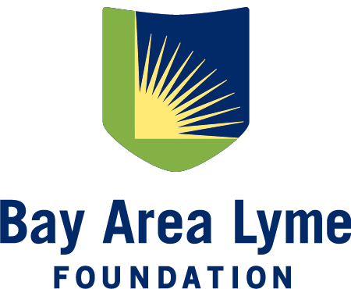

2027 Emerging Leader Award Grant Application
Please complete the following application and send it to award@bayarealyme.org by February 1, 2027. Include a research proposal of no more than 10 pages using the outline below. The page count excludes pages required for biosketch/CV and letters of support. Please submit all materials in one PDF file. File naming format should be “Last Name - Institution - Lyme or Tick-borne - 2027”. For additional questions about application submissions, please contact the Bay Area Lyme Foundation at award@bayarealyme.org or by phone at (650) 530-2439.
I. Contact Information
Applicant Name:
Applicant Professional Title:
Organization Affiliation:
Organization Type (select one):
- 501(c)3 Public university
- (170(c)) Other non--profit entity
- Other (please describe):
Address:
Email: Phone:
Application Type (select one):
- Lyme Disease
- Other Tick-borne Pathogen Research

Have you submitted this proposal elsewhere for funding? If yes, please list the organization and funding opportunity.
- Yes. Organization and funding opportunity:
- No

II. Applicant Biosketch/CV
Attach current CV or biosketch with application form.
III. Title of Proposed Project:

IV. Hypotheses and Specific Aims
Please ensure the key deliverable or prototype can be completed in 12–24 months ($150K award) . The start date would be approximately July or August 2027.

V. Research Strategy and Methods
Include an explanation of how the project would improve Lyme disease or other tick-borne illness diagnosis or treatment.

VI. Facilities and Resources
Outline the facilities you have access to complete the key deliverable and resources provided or funded through the grant.

VII. Project Timeline
Include a timeline with major milestones to complete the project within 12–24 months ($150,000 grant) from award date.

VIII. Project Budget
Please outline the cost of the project including personnel, materials, and other resources required to complete the key deliverable(s). (Note: It is the policy of the Bay Area Lyme Foundation to pay no more than 5% of any grant towards overhead or indirect costs.)

IX. Previous Projects that Support Proposed Work and Relevant Publications
Provide a description of supporting work by the applicant and/or collaborators.

X. Letter of Support
Application must include one letter of support from the current supervising manager. Additional letters are welcome.

