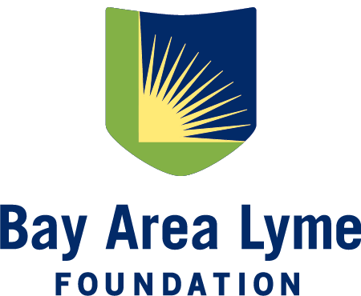
Research Grant Application
Bay Area Lyme Foundation accepts applications from universities, hospitals, and independent research entities in the United States. Awardees are evaluated on the ability of the research to positively impact patients, the applicant’s track record for project execution, potential for research to lead to a novel therapy or diagnostic for Lyme disease, and resourcefulness in bringing new vision into the field of Lyme disease research. Beyond diagnostic and therapeutic projects, we fund a limited number of ecology projects every year. Grant recipients do not need to have previous experience in Lyme disease research.

We request that grants be submitted according to the following time frames: Receipt by January 31 (to be reviewed by March 31); receipt by June 30 (to be reviewed by August 31); and receipt by September 30 (to be reviewed by November 30). If you would like pre-proposal feedback before submitting a full proposal package, please contact us at award@bayarealyme.org.

Please complete the following application and send it to award@bayarealyme.org. Your application should include a research proposal of no more than 10 pages (12-point font preferred) using the suggested outline below. For additional questions about application submissions, please contact our Research Grant Director at award@bayarealyme.org.

I. Contact Information
Applicant Name: _________________________________________________________________________________
Applicant’s Professional Title:_____________________________________________________________________
Organization Affiliation:__________________________________________________________________________
Organization Type: 501(c)3 Public university (170(c)) Other non-profit entity
If other, please describe: ________________________________________________________________
Address:_____________________________________________________________________________
City:__________________________________________State:____________ZIP:___________________
Email:_______________________________________________________________________________
Phone:_________________________________________Fax:__________________________________

II. Applicant Biosketch/CV
Attach current CV or biosketch with application form.
III. Title of Proposed Project:

IV. Background:
Please include detailed background on the science or technology underlying the proposal including successful use in other fields or indications.

V. Aims of Project:
Please describe the specific aims of the proposal including hypotheses, methods, and statistics.

VI. Project Timeline
Please include a timeline with major milestones to complete the project. A Gantt chart is helpful. Projects typically last 12-18 months.

VII. Project Budget
Please outline the cost of the project including personnel, materials, and other resources required to complete the key deliverable(s). (Note: It is the policy of the Bay Area Lyme Foundation to pay no more than 5% of any grant towards overhead or indirect costs.) There is no set budget limit.

VIII. Rigor & Reproducibility
Please describe the steps that you will take to ensure the research is rigorous and reproducible.

