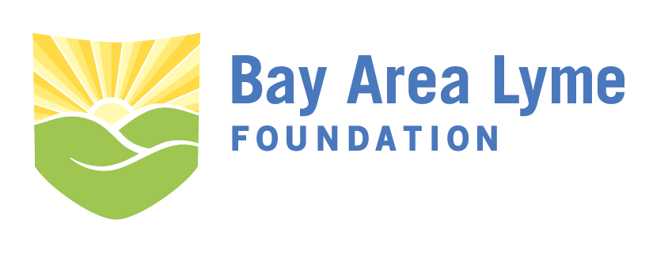
2023 Emerging Leader Award Grant Application
Please complete the following application and send it to award@bayarealyme.org. We will accept applications through February 15, 2023. Include a research proposal of no more than 10 pages using the outline below. Page count excludes pages required for biosketch/CV and reference letter.
For additional questions about application submissions, please contact the Bay Area Lyme Foundation offices at info@bayarealyme.org or by phone at (650) 530--2439.
I. Contact Information
Applicant Name: ______________________________________________________________________________
Applicant Professional Title:___________________________________________________________________
Organization Affiliation:________________________________________________________________________
Organization Type (circle one): 501(c)3 Public university (170(c)) Other non--profit entity
If other please describe: ________________________________________________________________________
Address:_________________________________________________________________________________________
City:__________________________________________State:____________ZIP:_____________________________
Email:___________________________________________________________________________________________
Phone:_________________________________________Fax:______________________________________________
II. Applicant Biosketch/CV
Attach current CV or biosketch with application form.
III. Title of Proposed Project:

IV. Hypotheses and Specific Aims
Please ensure the key deliverable or prototype can be completed in 12–24 . The start date would be approximately July or August 2023.

V. Research Strategy and Methods
Include an explanation of how the project would improve Lyme disease diagnosis or treatment.

VI. Facilities and Resources
Outline the facilities you have access to complete the key deliverable and resources provided or funded through the grant.

VII. Project Timeline
Include a timeline with major milestones to complete the project within 12–24 months from award date.

VIII. Project Budget
Please provide a detailed project budget including personnel, materials, and other resources required to complete the key deliverable(s). Note: It is the policy of the Bay Area Lyme Foundation to pay no more than 5% of any grant towards overhead or indirect costs, and not to pay for related travel costs

IX. Previous Projects that Support Proposed Work and Relevant Publications
Provide a description of supporting work by the applicant and/or collaborators.

X. Letter of Reference
Application must include a letter of reference from your current supervising manager.

