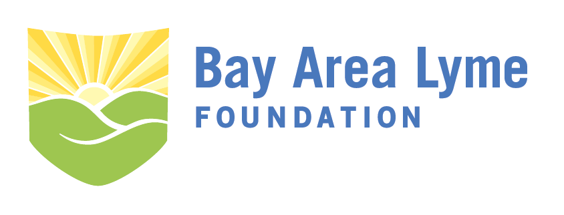
Research Grant Application
The Bay Area Lyme Foundation accepts research grant applications year round on a rolling basis. Please complete the following application and send it to award@bayarealyme.org. Your application should include a research proposal of no more than 10 pages (12 point font preferred) using the suggested outline below.
For additional questions about application submissions, please contact the Bay Area Lyme Foundation offices at info@bayarealyme.org or by phone at (650) 530-2439.

I. Contact Information
Applicant Name: ______________________________________________________________________
Title:________________________________________________________________________________
Organization Affiliation:_________________________________________________________________
Organization Type: 501(c)3 Public university (170(c)) Other non--profit entity
If other please describe: ________________________________________________________________
Address:_____________________________________________________________________________
City:__________________________________________State:____________ZIP:___________________
Email:_______________________________________________________________________________
Phone:_________________________________________Fax:__________________________________
II. Applicant Biosketch/CV
Attach current CV or biosketch with application form.

III. Title of Proposed Project:

IV. Background:
Please include detailed background on the science or technology underlying the proposal including successful use in other fields or indications.

V. Aims of Project:
Please describe the specific aims of the proposal including hypotheses, methods, and statistics.

VI. Project Timeline
Please include a timeline with major milestones to complete the project. A Gantt chart is helpful.

VII. Project Budget
Please outline the cost of the project including personnel, materials, and other resources required to complete the key deliverable(s). (Note: It is the policy of the Bay Area Lyme Foundation to pay no more than 5% of any grant towards overhead or indirect costs.)

