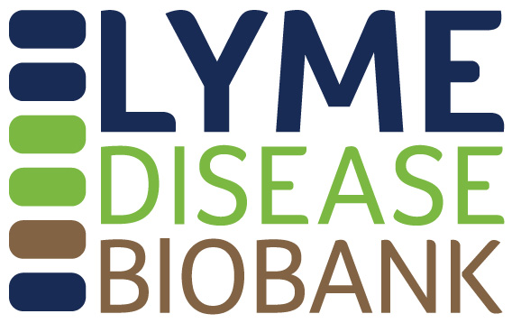

Lyme Disease Biobank Unblinded Discovery Panel Application

Part I. CONTACT INFORMATION

PI Name:

Title:

Institution/Organization:

Address:

Phone number:

Alternate phone number (if applicable):

Email:

Website:

Alternate/Assistant’s contact information (if applicable):

Part II: PROJECT INFORMATION

Project Title:

Co-investigators/Collaborators (if applicable):

Funding source for this work:

Timing of when you anticipate conducting this research:

Submission Date:

Please attach a current copy of PI’s CV.
Part III. SUMMARY
Please summarize how you will use the unblinded panel, including the research question you are trying to answer, the assay that you will be using, and how the unblinded panel will help you further your research program. (Limit 300 words)

Part IV. PROJECT DETAILS (limit 2 pages)
Please answer the following questions for your use of the unblinded panel.

- Sample type requested:
Serum (250 μl)
Whole blood (1 ml)
Whole blood (2 ml)
Urine (1 ml)

- State your research question.

- Describe your assay including how positive calls will be made (if known).

- Have you tested your assay with human samples?
Yes
No

If yes, please describe your preliminary results, including the types of samples that have been tested and how they were characterized/validated for Lyme disease.

- Tell us how the unblinded panel will help advance your research.

- Provide a timeline for testing the unblinded panel.

Part V: IRB STATUS
Include a copy of the approval letter from your current Institutional Review Board (IRB) indicating that the proposed analysis plan was approved by the IRB, granted an exemption by the IRB, or determined to be non-Human Subjects Research by the IRB. All samples will be provided deidentified. Note: Applications can be reviewed without IRB approval, however IRB approval or exemption is required prior to releasing samples or data to approved investigators.

Please submit to Liz Horn, PhD, MBI, at info@lymebiobank.org.

