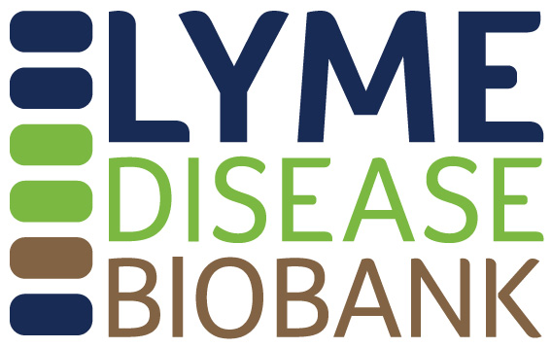

Lyme Disease Biobank Sample Access Application

Part I. CONTACT INFORMATION

PI Name:

Title:

Institution/Organization:

Address:

Phone number:

Alternate phone number (if applicable):

Email:

Website:

Alternate/Assistant’s contact information (if applicable):

Part II: PROJECT INFORMATION

Project Title:

Co-investigators/Collaborators (if applicable):

Funding source for this work:

Timing of when you anticipate conducting this research:

Submission Date:

Please attach a current copy of PI’s CV.
Part III. SUMMARY
Please describe the proposed use of the samples in lay language, including the research question you are trying to answer and how Lyme Disease Biobank samples will help you answer that question. (Limit 500 words)

Part IV. PROJECT DETAILS
Please describe the technical details of the project, including the research question, analysis plan including methods, statistics (including justification for the number of samples you are requesting), timelines, possible findings, and publication strategy. Applicants are encouraged to include preliminary data in their proposals. Diagnostics proposals will be prioritized over basic science proposals. Technical details shared with the Lyme Disease Biobank will be kept confidential. (Limit 5 pages, 3 pages preferred)

Please be sure to answer the following questions in your application:
- State your research question.

- Describe your assay including how positive calls will be made.

- Provide preliminary data supporting your use of LDB samples, including what samples have been previously tested and how they were obtained and characterized.

- List the samples you are requesting (see checklist chart for more information).

- Provide statistical justification/power calculation for your sample request.

- Describe how the LDB samples will be used.

- Provide a timeline.

- Provide a publication/dissemination strategy.

Part V: IRB STATUS
Include a copy of the approval letter from your current Institutional Review Board (IRB) indicating that the proposed data analysis plan was approved by the IRB, granted an exemption by the IRB, or determined to be non-Human Subjects Research by the IRB. Note: Applications can be reviewed without IRB approval, however IRB approval or exemption is required prior to releasing samples or data to approved investigators.

Please submit to Liz Horn, PhD, MBI, at info@lymebiobank.org.

