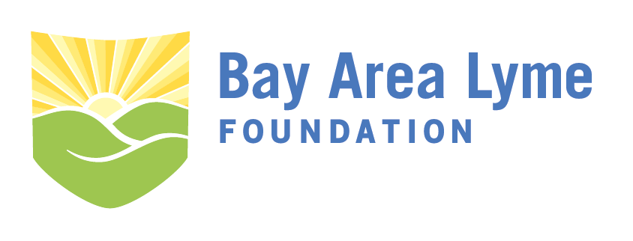
2018 Emerging Leader Award Grant Application
Please complete the following application and send to award@bayarealyme.org by February 28, 2018. Include a research proposal of no more than 10 pages (minimum 10 pt font, double or single spacing) using the outline below. Applications longer than 10 pages (excluding pages required for references, biosketch or CV) will not be eligible for this grant. The award will be presented to the winner in late spring 2018 at our annual LymeAid event.
For additional questions about application submissions, please contact the Bay Area Lyme Foundation offices at info@bayarealyme.org or by phone at (650) 530-2439.
I. Contact Information
Applicant Name: ______________________________________________________________________
Title:________________________________________________________________________________
Organization Affiliation:_________________________________________________________________
Organization Type: 501(c)3 Public university (170(c)) Other non--profit entity
If other please describe: ________________________________________________________________
Address:_____________________________________________________________________________
City:__________________________________________State:____________ZIP:___________________
Email:_______________________________________________________________________________
Phone:_________________________________________Fax:__________________________________

II. Applicant Biosketch/CV
Attach current CV or biosketch with application form.

III. Title of Proposed Project:

IV. Hypotheses and Specific Aims
Please ensure the key deliverable or prototype can be completed in 12–18 months for the $100,000 award or 18-24 months for the $250,000 award. The projected funding date is around May 2018.

V. Research Strategy and Methods
Include explanation of how the project would improve Lyme disease diagnosis or treatment.

VI. Facilities and Resources
Outline the facilities you have access to complete the key deliverable and resources provided or funded through the grant.

VII. Project Timeline
Include a timeline with major milestones to complete the project within 12–18 months ($100,000 grant) or 18-24 months ($250,000 grant) from award date.

VIII. Project Budget
Please outline the cost of the project including personnel, materials, and other resources required to complete the key deliverable(s). (Note: It is the policy of the Bay Area Lyme Foundation to pay no more than 5% of any grant towards overhead or indirect costs.)

IX. Previous Projects that Support Proposed Work and Relevant Publications
Provide a description of supporting work by the applicant and/or collaborators.

X. Letter of Reference
Application must include a letter of reference from your current supervising manager.

